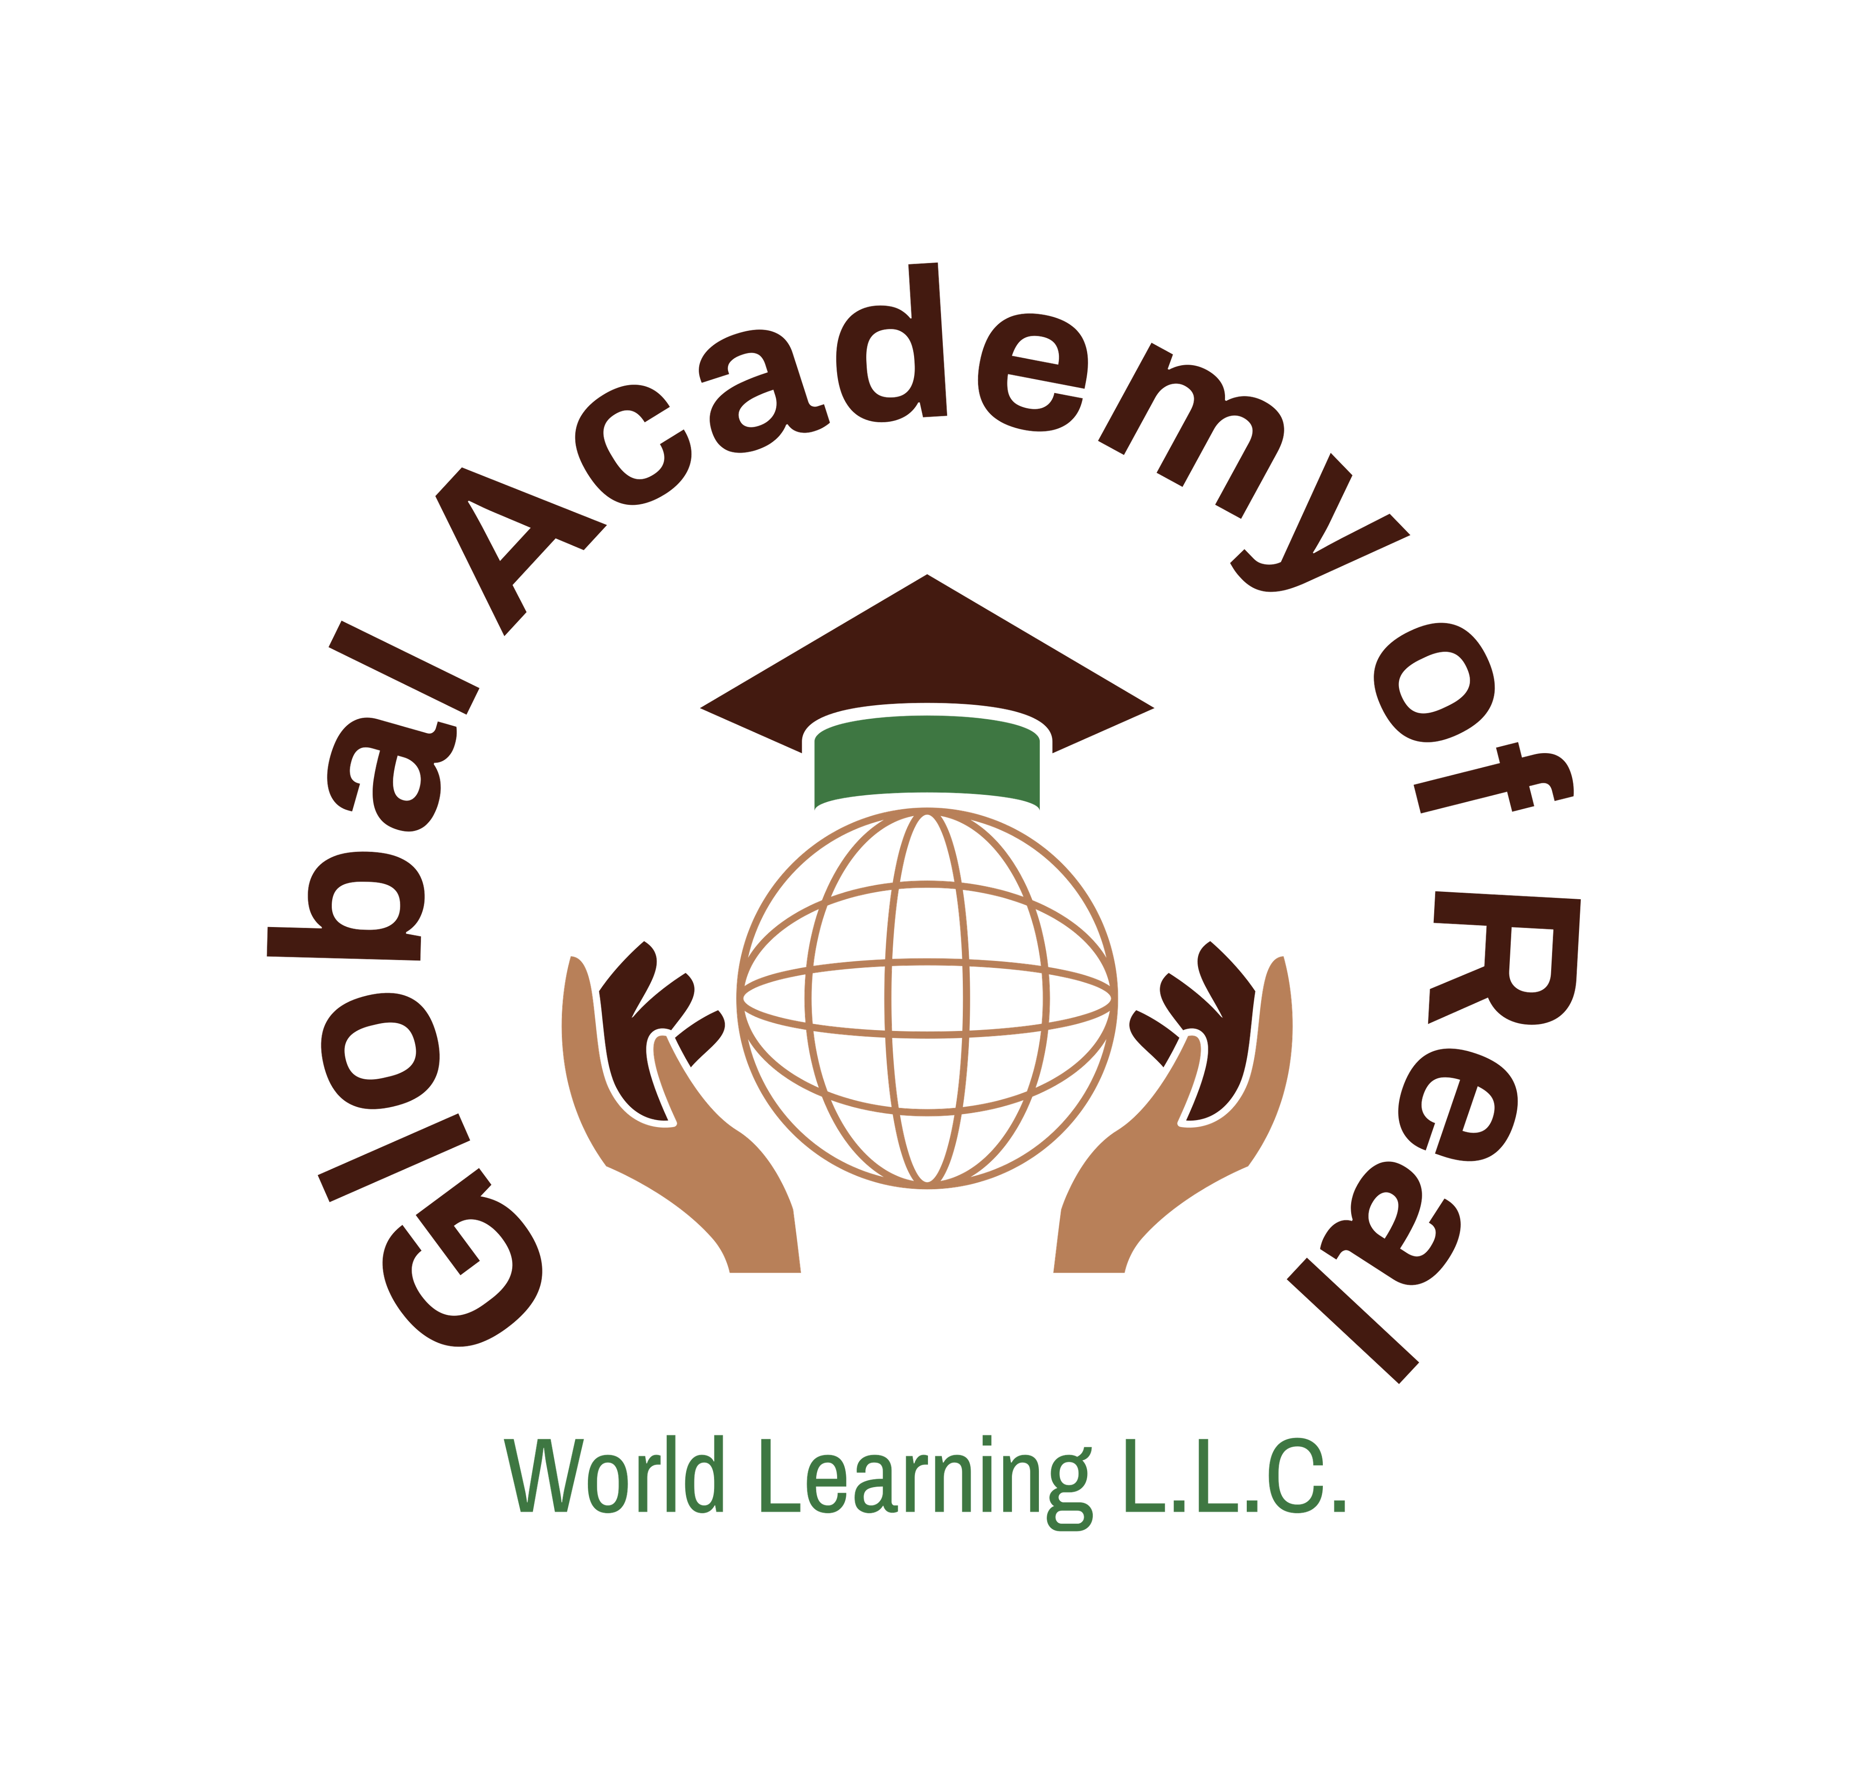

Parent/Guardian Consent Form

Global Youth Virtual Sustainability Program

Program Overview
The Global Youth Virtual Sustainability Program, hosted by the Global Academy of Real World Learning (GARWL), is a six-week virtual summer initiative running from the second Saturday of August through the second Saturday of September.
The program brings together students from Africa, the Caribbean, and the United States to collaborate in international teams. Each week, students will meet virtually via Zoom to explore the following themes:

Weekly Themes
- Recycling and Plastic Waste Management
- Infrastructure & Environmental Resilience
- Sustainable Agriculture and Clean Energy
- Sargassum Seaweed Crisis in Barbados
- Land Preservation and Cocoa Farming
- Final Presentations & Global Youth Summit

Program Format
- Duration: 6 consecutive Saturdays
- Platform: Virtual (Zoom)
- Structure: Mixed international student teams
- Activities: Weekly discussions, research assignments, team collaboration, and project presentations
- Outcome: Students will develop and present sustainability projects while gaining global cultural awareness

Benefits for Students
- Exposure to sustainability challenges and solutions
- Development of teamwork and leadership skills
- Cross-cultural collaboration with peers from different countries
- Opportunity to build a portfolio project for academic and career growth
- Certificate of Completion awarded at the end of the program

Consent & Acknowledgment
I, the undersigned, as the parent/guardian of the participating student, hereby:
1. Consent to my child’s participation in the Global Youth Virtual Sustainability Program.
2. Acknowledge that this program will be conducted entirely online, and I will ensure my child has reliable internet access and a quiet space for participation.
3. Understand that all virtual sessions may be recorded for educational and promotional purposes by GARWL.
4. Release GARWL, its affiliates, and program partners from liability for any technical issues, interruptions, or outcomes arising from participation.
5. Acknowledge that it is my responsibility to supervise my child’s participation and ensure appropriate conduct during virtual sessions.

Student Information
Student Name: ________________________________________
Age: ________ Grade Level: ___________________
Country: _________________________________________________

Parent/Guardian Information
Name: ________________________________________________
Relationship to Student: ________________________________
Phone Number: _________________________________________
Email Address: _________________________________________

Signature
I hereby give my full consent for my child to participate in the Global Youth Virtual Sustainability Program.
Parent/Guardian Signature: _____________________________ Date: _____________
Student Signature: _________________________ Date: _____________

